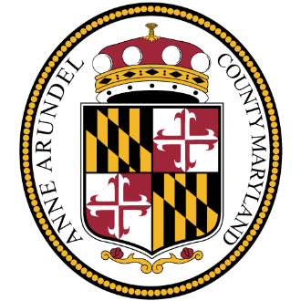

Office of the County Executive
Steuart Pittman

FOR IMMEDIATE RELEASE  November 13, 2020 | MEDIA CONTACT  Roz Hamlett  Public Information Officer  410.279.4748/roz.hamlett@aacouonty.org  Catie Comer  Director of Development & Communications  410.384.4072 / ccomer@thearcccr.org
THE ARC CENTRAL CHESAPEAKE REGION AND ANNE ARUNDEL COUNTY PARTNER TO HELP CHILDREN WITH DISABILITIES

COUNTY EXECUTIVE PITTMAN ANNOUNCES $45,000 AVAILABLE IN COVID-19 FUNDING

SEVERN, MD, (November 13, 2020) - Today, County Executive Steuart Pittman announced a partnership with Arc Central Chesapeake Region (The Arc) that will offer grants to families with children with disabilities or special medical needs who are adversely affected by COVID-19.

The program will provide short-term, in-home support to children (ages 0-21) with disabilities living in Anne Arundel County. The Arc is a nonprofit committed to transforming lives for people with intellectual and developmental disabilities. Families are eligible to receive up to $500. The Arc will begin accepting applications for the program on Friday, November 13, 2020. Families may apply for the funding through December 31, 2020.

"This program will provide parents and caregivers the freedom and in-home support to attend to their own health needs,” said County Executive Pittman. “This includes the ability to isolate or quarantine, or tend to important family and household matters while their children with disabilities receive appropriate care and support.”

Parents can apply for funding to provide childcare to complete necessary personal tasks such as medical or other critical appointments, childcare to help as they recover from COVID-19, support to provide supervision during virtual learning so parent(s) can work, childcare to complete basic tasks that cannot be completed with their child, or childcare to allow for a mental break.

“We are thrilled to partner with Anne Arundel County to provide this incredible funding for our community,” said Jonathon Rondeau, President & CEO, The Arc. “This program will help parents who need additional support for their child due to the pandemic, and is a much-needed resource for so many families in our community at this time.”

Families can apply at www.thearcccr.org/familysupportsgrant through December 31, 2020.

About The Arc Central Chesapeake Region
The Arc Central Chesapeake Region provides services and supports to people with intellectual and developmental disabilities through living options, workforce development and fiscal management services. Serving Anne Arundel County and the Eastern Shore of Maryland, The Arc provides an innovative, person-directed approach across the arc of a person’s life with a focus on equity and self-determination. www.thearcccr.org

